**TRANSATLANTIC NETWORKS OF EXCELLENCE**

**Midterm Progress Report**

*Due at least 4 weeks before the midterm review.*

*The complete report should be submitted in PDF format.*

1. **Program Identification** Program Title:

Grant number:

Start Date:

Principal Coordinator and Institution:

Network Administrative Officer:

Second Coordinator and Institution:

*Changes in Network members since the last report (initial term):*

1. **Work to date**

**1. Narrative summary.**

Please provide a **2-page** narrative summary of the progress of the network since the initial term report. Be sure to comment on any modifications to:

* 1. the general aims/objectives of the network;
  2. the scientific program;
  3. the membership of the network.

*Include an explanation of why these changes have been made or are being contemplated.*

1. **Major accomplishments to date.**

In this section, please provide a more detailed summary of the work performed with respect to the network’s specific research objectives. If the network’s objectives have changed since the initial term report, organize the report with the list of revised objectives or aims. This section should be organized, as appropriate, by aim/objective, or laboratory.

***Please cite relevant publications in the text*.**

*This section should be brief, but written with enough detail that other scientists may evaluate the work of the network. However, the inclusion of complex methodologic summaries reproduced from published articles is not desirable, nor is it necessary to repeat aspects of the original application. Rather, this section should be a synthesis of the scientific work of each member, or aim/objective. This report helps introduce your Network to the Review Committee, and provides a framework for understanding and evaluating your scientific accomplishments since the initial term report. Each member/laboratory or aim/objective should be no longer than 2 to 3 paragraphs, maximum. Feel free to use bullet points rather than long sentence*

1. **Plans for future work**.

(2 pages maximum) Outline the work plan for the remaining years of grant support including new projected milestones. This narrative should follow in the same format used in the summary of the major accomplishments to date (Section II:2 above), organized by aim/objective, or laboratory section. Please be sure to keep this outline separate from the discussion in the previous section about your major accomplishments to date.

1. **Glossary of abbreviations used, if applicable**

1. **Network organization and function** 
   * 1. **Collaborations.** Please describe ongoing collaborations, exchange of personnel among network members, and joint work within the network.

Include plans for collaborative work for the remainder of the term.

**1a.** Highlight the advantages of the collaborative effort to the overall program thus far: what was accomplished through collaboration that would not have been done by the individual members working independently?

**1b.** Specify resources that were shared among laboratories (reagents, techniques, animals, databases, etc.).

**1c.** In addition, please include a metric or tabulation of network collaborations per term *(one possible example is below)*:

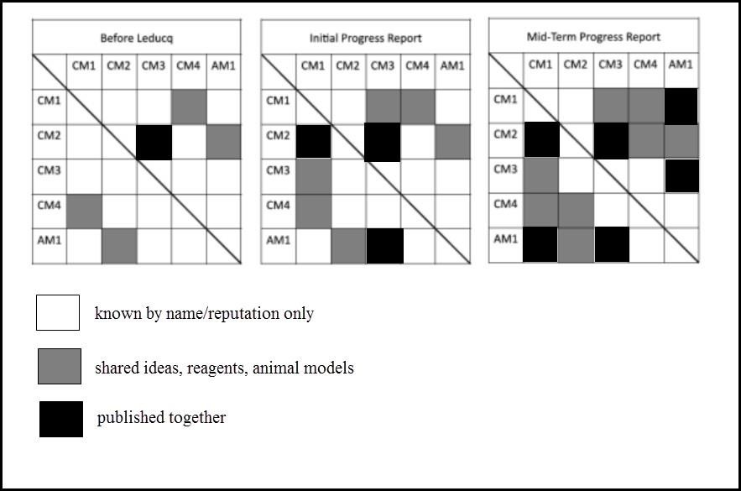

* + 1. **Describe the communication plan for the network.**

Minutes or summaries of meetings, virtual or real, held by the network should be included as an appendix.

* + 1. **Early Career Investigators.** 
       - * Discuss the role of early career investigators (undergraduate, graduate and medical students; post-doctoral fellows) in network projects.
         * For each early career investigator, list their **full name** (first, middle initial, last), **ORCID number** and the **% of their effort** supported by the TNE grant. *(If an early career scientist is doing work within the network but is not being paid from the Leducq grant, please include their name as well, listing 0% as funding amount).*
         * List any relevant accomplishments such as publications, programs in place to promote their career development, and plans for their involvement in ongoing or future network research.
         * *Feel free to use bullet points.*

**4**. **Personnel Report** (see page 5).

1. **Budget**

**1. Current year**.

* + - * + Please provide a summary, by year, of the actual amount spent by each member in the network up through the end of the last quarter for which spending information is available.
        + Follow the budget template provided (page 6).
        + Please provide a justification for any significant discrepancies that have arisen since the last progress report.

**2. Revised future budget**.

If applicable, please provide a revised budget for the remaining years of support. Provide a Global Budget summary with a breakdown per institution and individual Investigator Budgets using the same templates as Exhibits 3 and 4 of the Research Agreement. Justify, briefly, changes from the original budget. All budgets should be sent in *both*PDF and Excel format.

1. **Network productivity and recognition 1. Publications.**

***Publications based on work funded by the Leducq Foundation, and which acknowledge the foundation’s support.***

• List *by year and then alphabetically by first author****,*** any publications related to work supported by and/or acknowledging the Leducq Foundation. Please indicate with an asterisk (*) those publications that represent a collaboration of two or more network members. PLEASE USE FULL NAMES

o *This should be a continuation of the list that began with the initial term report. New publications should be appended to this list, with appropriate changes if necessary, e.g. full journal citation instead of “submitted” or “in press.” Thus, this list, which began with #1, should be amended and added to; continue numbering the Leducq cited/acknowledged papers throughout the upcoming 5 years.*

***Please ensure that citations include ALL authors.***

o *If an article has more than 20 authors, please only list the first and*

*last author and any Leducq Network authors. Please make a notation*

*next to such articles to indicate this option was done.*

* + 1. **Inventions, patents, licenses**.

Please list, by year, any inventions, patent applications, copyrights, licenses, sales or revenue-generating agreements concerning inventions, discovered or arising out of research supported by Leducq Foundation, as indicated in the Research Agreement.

*Please note: You may take the list you started with the first term report, and add to it, indicating the newer reporting period.*

* + 1. **Awards or Honors.**

Please list, by year, any award or honor granted to a network member or to any person involved in the work performed.

*Please note: You may take the list you started with the first term report, and add to it, indicating the newer reporting period*

* + 1. **Extramural funding.**

Please provide the **sources** and **amounts** of any extramural funding obtained by network members since the last report, and indicate whether this funding will apply to projects related to Leducq Foundation-supported research with an *.

1. Please comment on anything else that you think the Leducq Foundation should know as it considers the progress of the network.

|  |  |
| --- | --- |
|  |  |
|  |  |
| Signature and date Principal Coordinator | Signature and date Second Coordinator |

Signature and date Network Administrative Officer

**PERSONNEL REPORT**

* + Please provide information below on personnel supported, wholly or in part, by Leducq Foundation funding.
  + For the purpose of this report, NETWORK EXCHANGE is defined as a person traveling to and visiting with another member of the Network for scientific interchange, apart from the Network meetings.
  + *For any member (not early career), new to the network, please provide a biosketch.*
  + For early career investigators, include the name of the senior person with whom they are working. Early career investigators, for purposes of this report, will include postdocs, fellows, and those researchers who have completed subspecialty training or been awarded a Ph.D. not more than 5 years ago.

o *This table should reflect the time duration since the last report.*

|  |  |  |  |  |
| --- | --- | --- | --- | --- |
|  | Full (first, middle initial  and last) Name  and Degree and ORCID number. | Current  Institutional Affiliation | % Total  Annual  Effort  Dedicated  to  Network | Network Exchange?  (Dates) |
| Coordinators |  |  |  |  |
| Members/Senior Investigators |  |  |  |  |
| Early Career Investigators  *Post-Docs*  *PhD students*  *Medical fellows/residents Medical or undergraduate students* |  |  |  |  |
| Technicians |  |  |  |  |
| Clinical research nurses |  |  |  |  |
| Administrative Staff |  |  |  |  |

**March 28, 2022**

